Wireless Access Networks

WLAN Technology
 known as WiFi, or IEEE 802.11
 standard defines (tanimlar)
– the physical layer (PHY)
– the data link layer – comprise (olusmak) of two sub-layers:
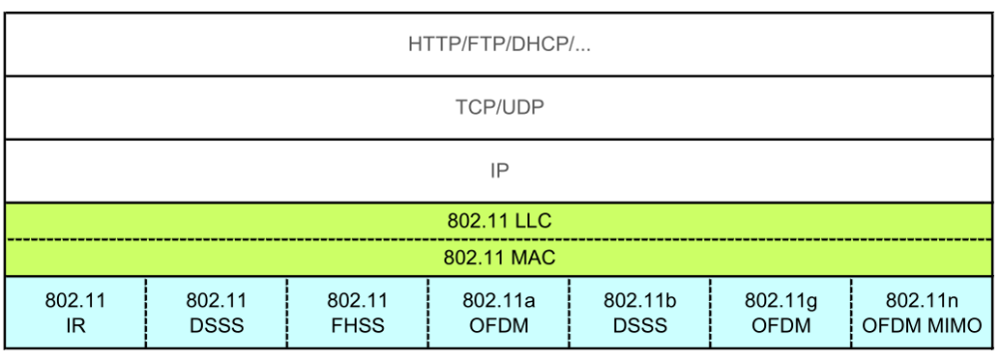

Physical Layer
 the physical layer defines the spectrum technique and modulation
 ISM band 2400-2483,5 MHz
– FHSS (Frequency Hopping Spread (yayilma) Spectrum)
• 79 channels, each (her biri) 1MHz
• 400 ms is time for transmitting
• lower bitrates than DSSS
– DSSS (Direct Sequence Spread (yayilma) Spectrum)
• use of XOR operation
• the bitrate is spreaded -> chiprate
– OFDM (Orthogonal Frequency Division Multiplexing)
• large number of closely (yakinca) spaced orthogonal sub-carrier signals are used
• robust (dayanikli) against fading (zayiflama) and multipath propagation (cok yollu yayilim)
Link Layer
 defines structure of frame, access method, multiplexing technique, error protection and ciphering (sifreleme)
 two sublayers are defined:
– LLC (Logical Link Control)
– MAC (Media Access Control)
 MAC layer
– defines access method, frame structure and protection
– Access Methods
• DCF (Distributed Coordination Function), based on CSMA/CA
• RTS/CTS (Request To Send / Clear To Send)
• PCF (Port Coordination Function)
 3 categories of frames are defined on MAC sublayer
– management – function of WLAN (Association (birlesme) Request, Beacon (isaretleme, isaret), Association Response (yanit) )
– control – function of access method (RTS, CTS, ACK)
– data – transmission of frames
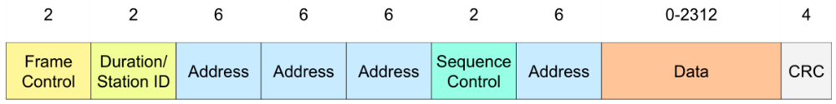

 IEEE 802.11 defines the family of specifications (ozellikler):
– 802.11
• applies (uygulamak) to wireless LANs and provides 1 or 2 Mbps transmission in the 2.4 GHz band using either frequency hopping spread spectrum (FHSS) or direct sequence spread spectrum (DSSS)
– 802.11a
• an extension (genisleme, uzatma) to 802.11 that applies to wireless LANs and provides up to 54 Mbps in the 5GHz band

– 802.11b
• 1999, ISM band 2.4 GHz,
• up to 11 Mb/s, DSSS on physical layer, 14 channels defined
• 5 MHz span (mesafe, sure) between each channel
• 22 MHz bandwidth of each channel
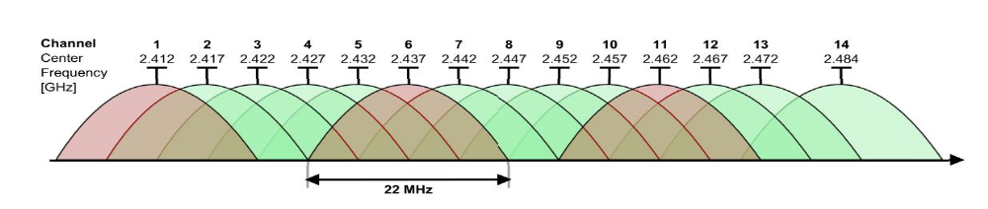
– 802.11g
• uses the OFDM, back compatibility (geri uyumluluk) to 802.11b
• up to 54 Mb/s
– 802.11n
• builds upon (uzerine) previous 802.11 standards by adding MIMO (multiple-input multiple-output)
• MIMO is a method for multiplying (cogaltmak) the capacity of a radio link using multiple transmit and receive antennas (antenler) to exploit (kullanmak, faydalanmak) multipath propagation (yayilma)
• offers high throughput (verimlilik) wireless transmission at 100Mbps – 200Mbps.
– 802.11ac
• reservation of multiple 20 MHz channels
• primary 20 MHz channel is always choosen (transmitting of Beacon (isaret) )
• total bandwidth is adaptively (uyarlamali olarak) changes based on actual (guncel) level in interference (etkilesim)
• up to 160 MHz
• up to 256-QAM
 802.11ad
– in 2008 TGad workgroup under IEEE established
– addon (eklenti) to 802.11 with the aim (amac) of working in 60 GHz band
– also as WiGig
– up to 7 Gb/s.
 802.11ah
– for IoT and M2M support
– 863 – 868 MHz
– 1 MHz or 2 MHz channel bandwidth
– up to 8 Mbps, commonly (cogunlukla) ~ 1Mbps

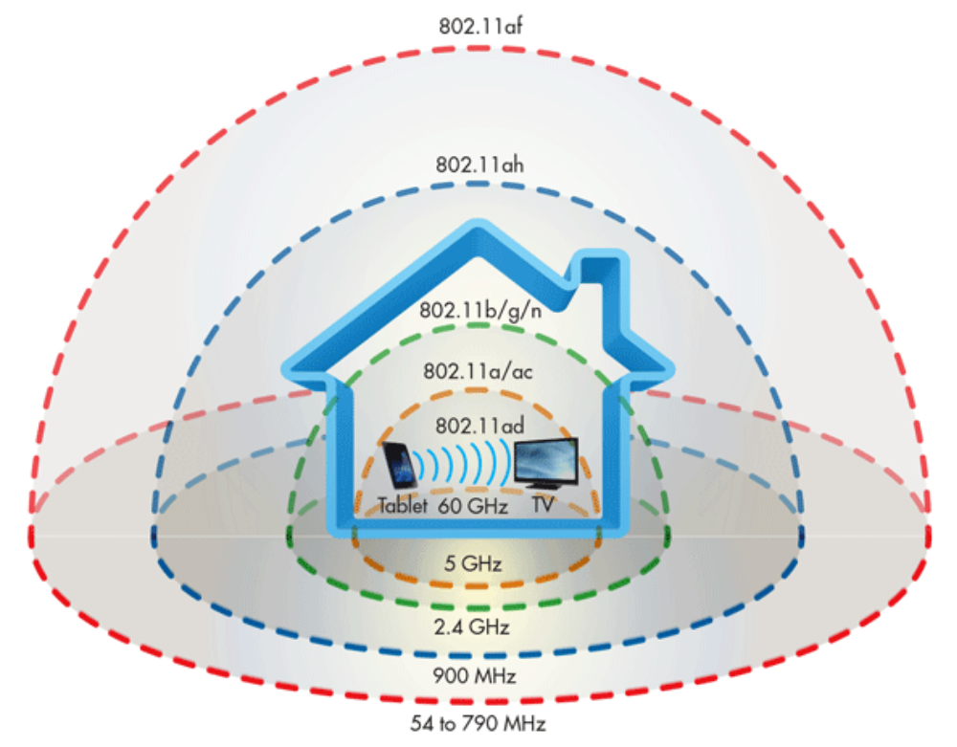

Comparison (karsilastirma) of frequency band and range for 802.11 family standards

 802.11 standard defines two operating (calisma) modes:
– Infrastructure (altyapi) mode - in which wireless clients are connected to an access point
– the set-up (kurulum) formed (olusturmak) by the access point and the stations located within its coverage (kapsama) area are called the basic service set (BSS).
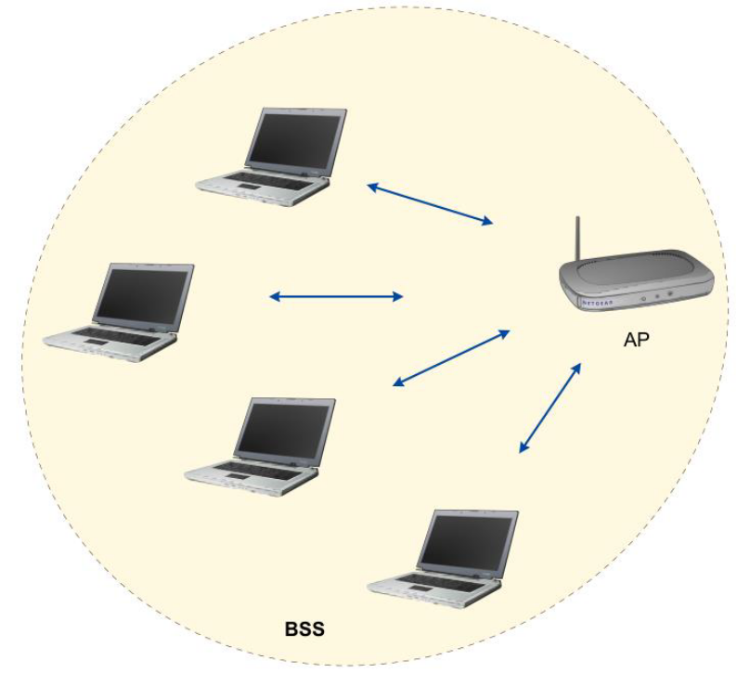

• Ad hoc (gecici) mode - clients are connected to one another without any access point

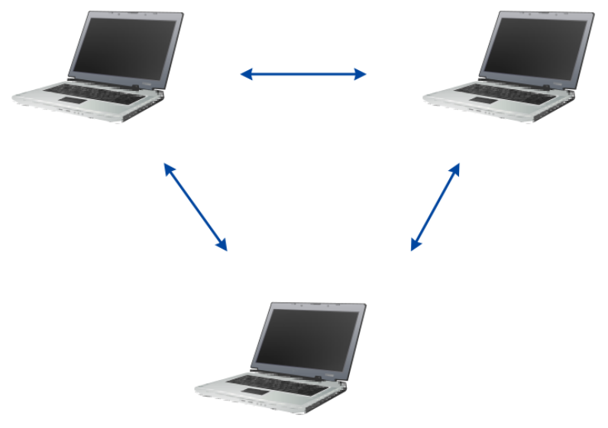
WLAN Network Security
 SSID blocking
 Filtering MAC addresses
– The configuration of access points generally allow them to keep a list of access permissions (called the ACL, for Access Control List) based on the MAC addresses of the devices authorised (yetkili) to connect to the wireless network
 WEP - Wired Equivalent (esdeger) Privacy
– data frame encryption protocol that uses the symmetrical algorithm RC4 with 64-bit or 128-bit keys
– cracked!
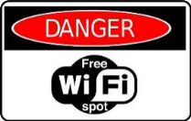
 WPA - WPA - WiFi Protected Access
– relies on (dayanmak) a strong encryption algorithm TKIP (Temporary (gecici) Key Integrity (butunluk) Protocol)
– TKIP generates (uretmek, olusturmak) keys randomly and can alter (degistirmek) an encryption key several times a second (saniyede birkac kez) , for greater security
 802.11i / WPA2
– like WPA, it relies on (dayanmak) the TKIP + AES (Advanced Encryption Standard) - not RC-4
– created by WiFi Alliance (ittifak)
– use of a PSK (Pre-shared (on paylasimli) Key), which is stored at both the access point and the client devices
– or use an authentication (dogrulama, kimlik dogrulama) server, generally a RADIUS server (which stands for Remote Authentication Dial-in User Service (kisaltmasi) )
 802.1x / EAP
– can authenticate (dogrulamak) (identify) a user who wants to access a network
– this is done through (vasitasiyla) the use of an authentication server
– 802.1x is based on the EAP protocol (Extensible (genisletilebilir) Authentication Protocol)
– EAP protocol is used for transporting user identification (kimlik) information

WiMAX
 Worldwide (dunya capinda) Interoperability (birlikte calisilabilirlik) for Microwave Access
 ratified (onaylanmak) by the IEEE under the name IEEE 802.16
 last mile wireless broadband (genis bantli) access as an alternative to cable and DSL
 the goal of WiMAX is to provide high speed Internet access in a coverage (kapsama) range several kilometres in radius (yaricap)
 versions (since 2002):
– 802.16 (2001) – 10-66 GHz, up to 134 Mbit/s, BPSK, QPSK
– 802.16d (2004) - 2-11 GHz; up to 75 Mbit/s, OFDMA
– 802.16e (2005) mobile WiMAX, 2-6 GHz; up to 128 Mbit/s at 120 km/h
– 802.16m (2009), so-called WIMAX 2.0, last variant, 0,45-3,6 GHz, up to 300 Mbit/s, use of MIMO, up to 64QAM

 system architecture
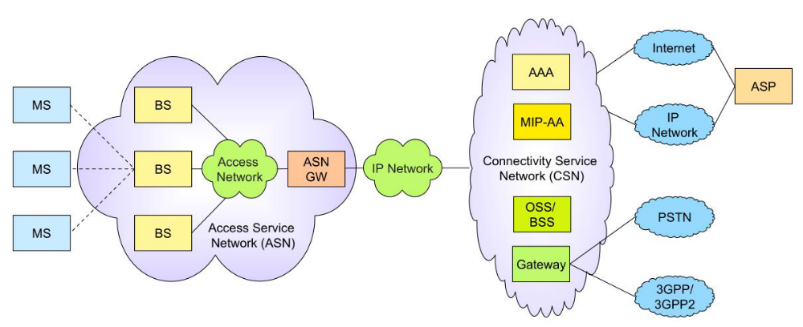
 Three main parts in architecture:
– MS (Mobile Station)
– ASN (Access Service Network)
– CSN (Connectivity Service Network)
• BS (Base Station)
• ASN-GW (Access Service Network Gateway)
• CSN (Connectivity Service Network)
Physical Layer
 support of duplex modes:
– FDD (Frequency Division Duplex)
– TDD (Time Division Duplex)
 following frequency bands are used:
– 450 - 470 MHz
– 698 - 960 MHz
– 1710 - 2025 MHz
– 2110 - 2200 MHz
– 2300 - 2400 MHz
– 2500 - 2690 MHz
– 3400 - 3600 MHz
 use od OFDM and MIMO
 use up to 64QAM

MAC Layer
 time-frequency map is defined, in which the frames are transmitted
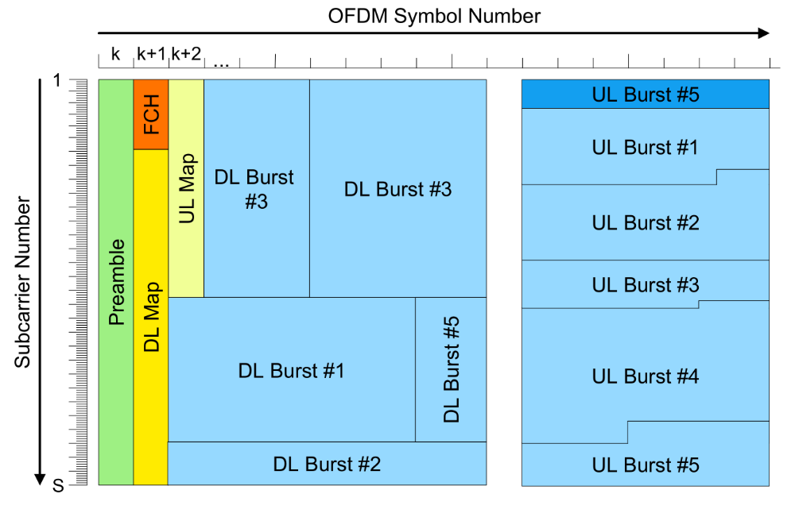
Bluetooth
 Wireless Personal Area Network Technology (WPAN)
 low-range (dusuk menzilli) wireless network technology used for linking devices to one another without a hard-wired (fiziksel baglantili) connection
 do not need a direct line of sight (gorus hatti) to communicate
 he aim is to transmit voice or data between devices with low-cost radio circuits, over a range of about ten to just under a hundred metres, using very little power
 designed mainly (baslica) for linking devices (such as printers, mobile phones, home appliances (ev aletleri) , wireless headsets, mouses, keyboards, etc.), computers, or PDAs to one another, without using a wired connection
 becoming more and more commonly (giderek yayginlasmak) used in mobile phones, allowing them to communicate with computers or PDAs

Operational modes
 master – slave (usta – kole)
 piconet
– a master (ana) can be simultaneously (ayni anda) connected to as many as (kadar cok) 7 active slave devices
 scatternet
– scatternets can be formed (olusturulmak) when a member of one piconet (either the master or one of the slaves) elects (secmek) to participate (katilmak) as a slave in a second, separate piconet
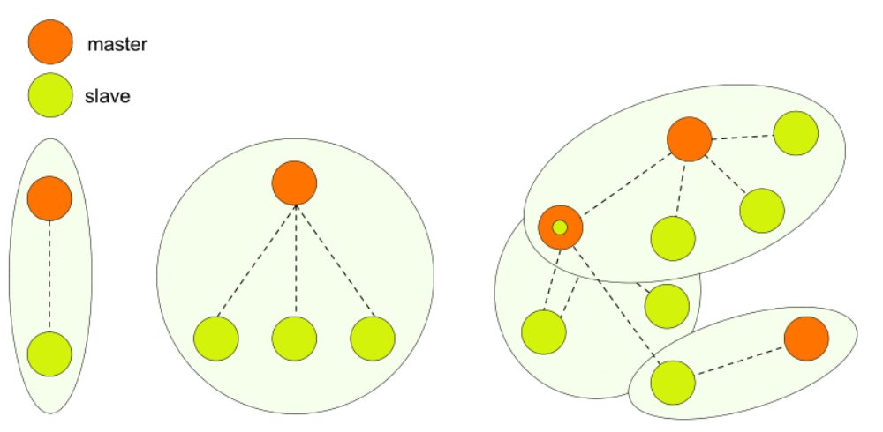

Protocol stack
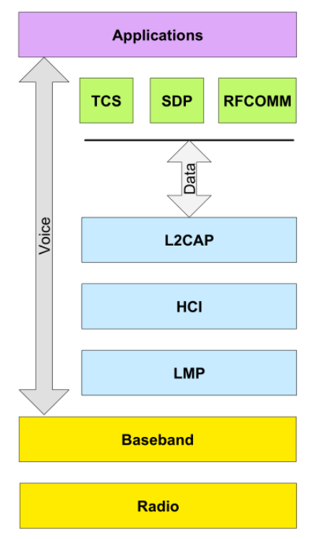
 Bluetooth radio
– 2,4 GHz frequency band
– GFSK (Gaussian Frequency Shift Keying) modulations with 1000 kBd,
– the FHSS technique (Frequency-Hopping Spread Spectrum), which splits (bolmek) frequency band of 2.402-2.480 GHz into 79 channels (called hops) each 1MHz wide
– 1600 hops (FHSS) per second in full duplex mode
– defines 3 classes of transmitters (verici), whose range varies (degistirmek) as a function of their radiating (yayilim) power
• Class 1 – up to 100 mW
• Class 2 – up to 2,5 mW
• Class 3 – up to 1 mW
 Bluetooth Baseband
– defines access mechanism for transmission medium, duplex method
 LMP (Link Manager Protocol)
– for procedures such as Inquiry (sorgulama), Paging (cagri) and Pairing (eslestirme, ciftleme)
 L2CAP (Logical Link Control and Adaptation Protocol)
• format of packet is defined
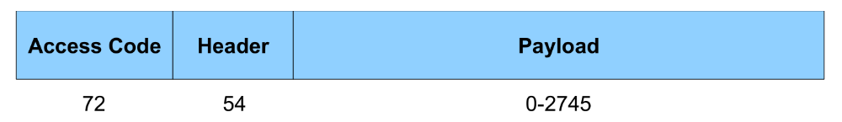
• Access Code (72 bits) – for synchronization
• Header (54 bits) – addressing, flow control, error protection
• Payload (0-2745 bits)
 RFCOMM (Radio Frequency Communication)
– emulating (benzetme) of RS-232 serial port
 SDP (Service Discovery (bulus, kesif) Protocol)
– for discovering (kesfetmek, bulmak) the Bluetooth equipment and its services

Bluetooth Versions

 Bluetooth 1.0 and 1.0B
 Bluetooth 1.1
 Bluetooth 1.2
 Bluetooth 2.0
 Bluetooth 2.1
 Bluetooth 3.0
 Bluetooth 4.0 (as BLE)
 Bluetooth 4.1
 Bluetooth 4.2
 Bluetooth 5 (2017)

Zigbee
 specification (tanimlama) for a suite (set, takim) of high level communication protocols using small, low power digital radios based on the IEEE 802.15.4-2003 standard
 wireless personal area network (WPAN), such as wireless headphones connecting with cell phones via (yolu ile) short-range radio
 simpler and less expensive than other WPANs, such as Bluetooth
 low-cost, low-power, wireless mesh (ag) networking standard
 operates in the industrial, scientific and medical (ISM) radio bands

Protocol Stack
 IEEE 802.15.4 defines PHY and MAC layer
 ZigBee Alliance (ittifak, birlik) defines network and security layer
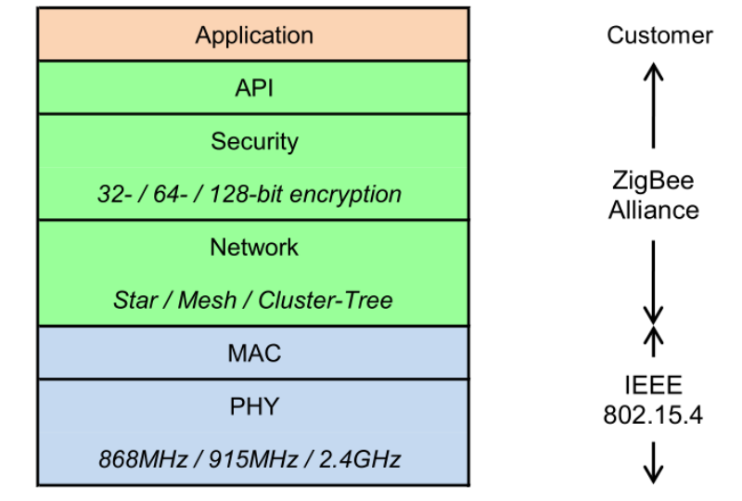

 Physical Layer
– use of BPSK or QPSK
– working band: 868 MHz, 902-928 MHz, 2400 MHz
 MAC layer
– synchronization, error protection, ciphering (sifreleme), management of frames
– frames divides into
• Beacon (isaret, radyo feneri)
• CAP (Contention (catisma) Access Period) and CFP (Contention Free Period)
• Inactive – low power mode
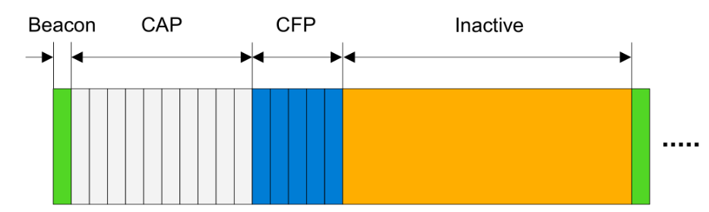
Topology
 support of star, tree and mesh (ag) topology
 node can operate as either a full-function device (FFD) or reduced function device (RFD).
 coordinator is an FFD and responsible for overall (tum) network management
 end device can be an RFD
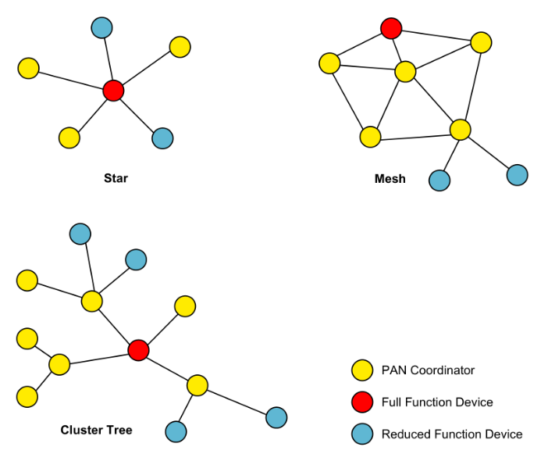
Technology for IoT
 A global infrastructure (altyapi) for the information society (toplum, topluluk), enabling (mumkun kilmak) advanced services by interconnecting (birbirine baglamak) (physical and virtual) things based on existing and evolving (gelisen) interoperable (birlikte calisilabilir) information and communication technologies.
 Cisco estimates (tahmin etmek) the IoT will consist of (olusmak) 50 billion devices connected to the Internet by (kadar) 2020
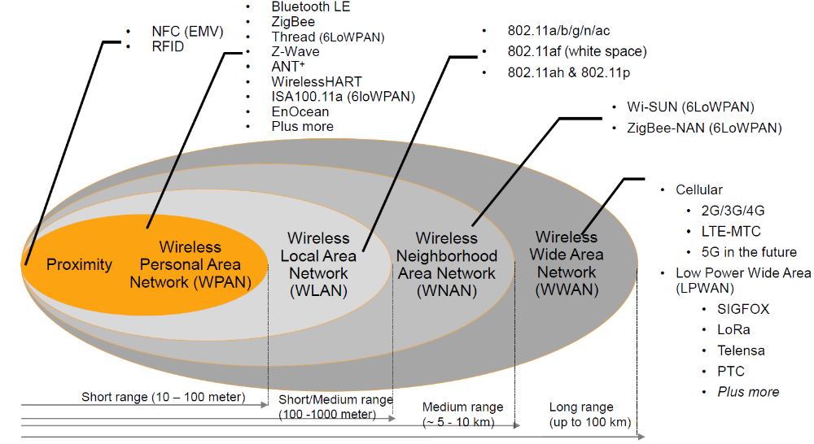

DVB-RCS
 Digital Video Broadcasting (yayin) - Return Channel via Satellite (Uydu üzerinden dönüş kanalı)
 it defines a complete (tam, eksiksiz) air interface specification (beyanname) for a two way satellite broadband (genis bant) scheme
 DVB-RCS HUB
– controls the system and acts as a traffic gateway between users and the Internet
 DVB-RCS terminal
– User terminals consist of a small indoor unit, and an outdoor unit with an antenna (anten)
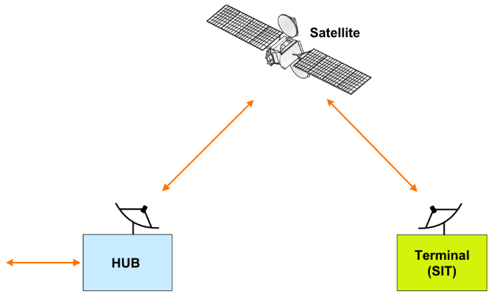
Physical Layer
 Forward Channel
– direction HUB → Transponder → Terminal
– QPSK
– C-band, Ku-band, Ka-band
– Ku-band most used (10,7 GHz - 12,75 GHz)
– use of TDM
– use of conventional DVB/MPEG2 frame
– up to 80 Mb/s
 Return Channel
– Terminal → Transponder → HUB
– QPSK
– C-band, Ku-band, Ka-band
– Ku-band most used (10,7 GHz - 12,75 GHz)
– use of MF-TDMA (Multi Frequency - Time Division Multiple Access
– up to 8 Mb/s

Transport stream
 MPEG2 has been universally adopted by DVB in all its varieties for source coding of video, audio and associated data information and for transmitting various source data streams in digital wrappers, also called digital containers
 the payload may be:
– IP traffic
– MPEG2 source coded information, also known as “native MPEG2”
– other bitstreams that comply with TCP/UDP
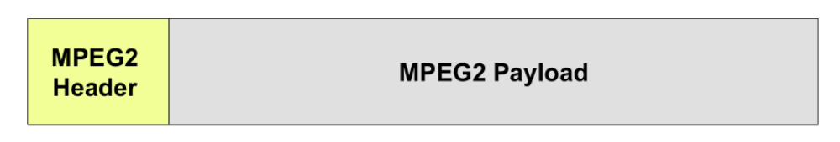

DVB-RCS2
 finished in 2011
 main improvements:
– BPSK, QPSK, 8PSK, 16-QAM
– ACM (Adaptive Coding and Modulation)
– use of Turbo-code

DECT
 Digital Enhanced Cordless Telecommunications
 ETSI standard for digital portable phones (cordless home telephones)
 band 1880 MHz–1900 MHz is used
 10 carriers with span of 1728 kHz
 FDMA/TDMA frame, where one frame is divided into 24 timeslots (2 x 12 up and down stream)
 audio codec G.726
 average transmission power 10 mW (250 mW peak) in Europe
 DECT Standard Cipher (DSC) used, the encryption is fairly weak, security algorithm has been broken

